**Information Visualization Exam 2**

(Total = 100pts)

**Student Name:** Sureh Babu Nakkalapalli  
**Student ID:** 811292428

**1. Visual cluttering is an important topic in information visualization. Please answer the following questions.**

**1.1 What is visual cluttering? Why does it happen? (10)**

**Ans:** Visual cluttering refers to an excess of visual elements or information within a space, such as a webpage or design layout, that makes it difficult for viewers to process information efficiently.

Visual clusters occur due to following reasons:

|  |  |
| --- | --- |
| **Factors** | **Description** |
| Overcrowding | The presence of too many elements within a limited space, overwhelming viewers' senses. |
| Lack of organization | Absence of clear hierarchy or structure, making it difficult for viewers to navigate the information |
| Complexity | Complex designs or layouts with intricate patterns, textures, or colors, leading to sensory overload |
| Ineffective use of whitespace | Poor utilization of whitespace, allowing unnecessary elements to encroach on important content. |
| Poor typography | Overuse of different fonts, sizes, or styles, making it challenging for viewers to read and understand the content |
| Inconsistent design elements | Lack of consistency in design elements like colors, shapes, and styles, creating visual discordance. |

**1.2 What are the effects of visual cluttering to information visualization? (10)**

**Ans:** The effects of visual cluttering on information visualization are as follows:

1. **Reduced Readability**: This shows a cluttered visualization where data points and text overlap, making it difficult to read and understand the information.
2. **Decreased Comprehension:** In a cluttered visualization obscures the patterns and trends within the data, leading to decreased comprehension.
3. **Impaired Decision Making:** The cluttered visualization here confuses the user, impairing their ability to make informed decisions based on the unclear information presented.
4. **Increased Cognitive Load:** T a user experiencing mental strain while trying to process the overwhelming amount of information presented in a cluttered visualization.
5. **Negative User Experience:** user encounters a cluttered visualization, resulting in a negative user experience due to the complexity of the display.
6. **Loss of Trust:** The user’s express skepticism and doubt about the accuracy and reliability of a cluttered visualization, leading to a loss of trust in the information presented.

**1.3 Please provide an example of visual cluttering in information visualization. Please also show the way it may be conquered or controlled. (20)  
This can be found by studying online or finding related papers. Provide the images illustrating your answer (a web link can also be provided) and write your description**.

**Ans:** Here's an example of visual clutter in information visualization from a research paper along with how it might be improved:

**Cluttered Visualization: Scatter Plot with Overlapping Points (from Measuring visual clutter:** **https://jov.arvojournals.org/article.aspx?articleid=2122001)**

The research paper "Measuring Visual Clutter" by Rosen Holtz et al. (2005) explores methods to quantify visual clutter in information visualization. One example they provide is a scatter plot with a high density of data points:

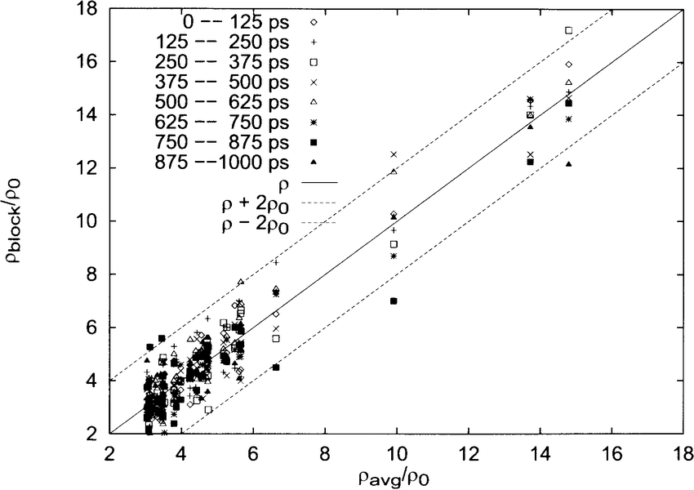

As you can see, the large number of overlapping data points makes it difficult to discern any patterns or trends in the data. This is a prime example of visual clutter because it hinders the user's ability to extract meaning from the visualization.

**Improved Visualization: Techniques to Reduce Clutter**

The authors propose several techniques to reduce clutter in scatter plots:

* **Jittering:** Slightly randomize the position of data points along the x or y axis while maintaining their original values. This helps to separate overlapping points and make them more distinguishable.

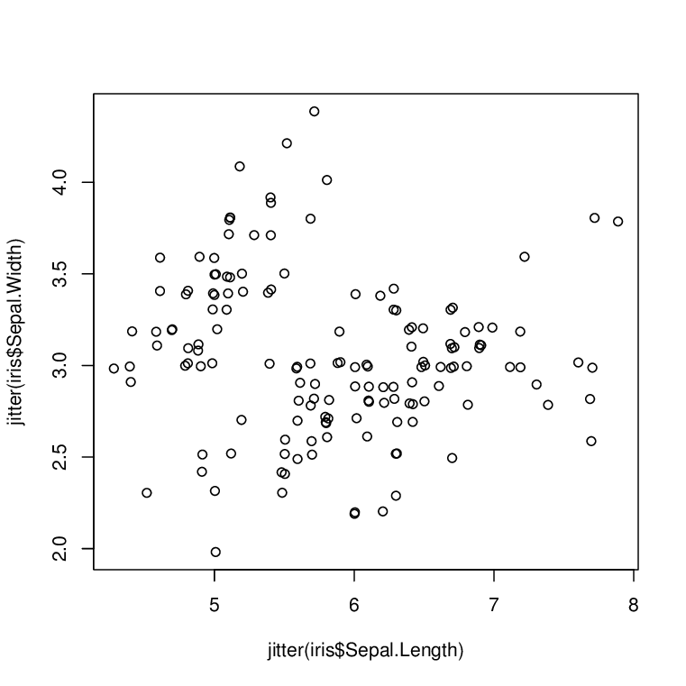

* **Brushing and Linking:** Implement interactive features that allow users to highlight specific subsets of data points. This helps to focus on areas of interest and reduce clutter in the overall view.

* **Hierarchical Clustering:** Group similar data points together and represent them with a single symbol or marker. This can be particularly useful for large datasets with many overlapping points.

By applying these techniques, we can create a scatter plot that is less cluttered and allows for easier identification of patterns and trends in the data.

This example from "Measuring Visual Clutter" demonstrates how a visualization can become cluttered due to an overwhelming number of data points. By implementing techniques like jittering, brushing and linking, or hierarchical clustering, we can improve the clarity and effectiveness of information visualizations.

**1.4 What are your own ideas about how the example in 1.3 can be further addressed? (10)**

**Ans:** Here are some additional ideas on how to address the visual clutter in the above mentioned scatter plot example:

* **Transparency:** Implementing transparency for data points can help reveal underlying patterns even with overlapping points. Denser areas will appear darker, allowing users to visually identify regions with higher data concentration.
* **Density Plots:** Consider using a density plot instead of a scatter plot. Density plots visualize the distribution of data points without individual markers. This can be a good option for large datasets where individual points get lost in the clutter.
* **Shape Coding:** Utilize shape coding to represent additional data attributes. For example, circle size could represent another data variable, allowing for a more information-dense visualization.
* **Color Mapping:** Employ color gradients to represent a third data variable. This can be particularly useful if there's a trend or correlation between the color and the data points' positions.
* **Interactive Features:** Go beyond brushing and linking. Allow users to zoom in on specific areas to see details or implement filters to focus on subsets of data based on different criteria.
* **Combining Techniques:** Don't be afraid to combine multiple approaches. Jittering with transparency or density plots with color mapping can be effective solutions depending on the data and the insights you want to highlight.

The best approach depends on the type of data, the message you want to convey, and your target audience. Consider these additional ideas and choose the technique that best reduces clutter while maintaining clarity and effectively presenting the data insights.

**2. Interaction is an indispensable part for a visual analytics system of big data. Please answer the following questions:**

**2.1 Why do we need interaction in information visualization systems? (10)**

**Ans:** Data can be overwhelming, and static visualizations have limits. Here's why interaction is crucial:

**Combating Overload:**

* **Limited Space, Big Data:** Zoom in, filter details, find hidden patterns.
* **Complexity Unveiled:** Explore layers, understand connections.

**Tailoring Your Experience:**

* **Goals Drive Insights:** Personalize the view for your specific needs.
* **Multiple Angles, One Truth:** Explore data from different perspectives.

**Enhancing Learning:**

* **Active Engagement, Deeper Understanding:** Learn by doing, test hypotheses.
* **Theory to Exploration:** Hands-on discovery for a stronger grasp.

**Improving Retention:**

* **Memorable Discovery:** Active learning leads to better information retention. Interaction bridges the gap between data and understanding.

|  |  |
| --- | --- |
| **Benefit** | **Description** |
| **Deeper Exploration** | Users can zoom in on specific data points, filter out irrelevant details, and uncover hidden patterns. |
| **Tailored Viewpoints** | Users can manipulate the visualization (switch views, reorder data, customize display) to suit their analytical goals and preferred perspectives. |
| **Improved Understanding** | Active manipulation fosters a dynamic learning process, allowing users to test hypotheses and gain a stronger mental grasp of the data. |
| **Knowledge Retention** | Interaction strengthens the connections between the data and the user's understanding, making information more memorable. |

**2.2 The following list shows four popular interactions. What are their tasks?   
 (20)  
 Filtering/Highlighting (5):  
 Pan & zoom (5):  
 Focus + context (5):  
 Labeling (5):**

**Ans : Tasks of Common Information Visualization Interactions**

Here's a breakdown of the tasks addressed by each interaction type:

* **Filtering/Highlighting:**
  + **Refine View:** Reduce information clutter by temporarily hiding irrelevant data points.
  + **Emphasize Trends:** Highlight specific data subsets to reveal patterns and trends.
  + **Comparative Analysis:** Compare and contrast different data categories by selectively highlighting them.
* **Pan & Zoom:**
  + **Navigate Large Datasets:** Move across extensive visualizations to focus on specific areas of interest.
  + **Inspect Details:** Zoom in to closely examine individual data points and their values.
  + **Gain Context:** Zoom out to regain a broader perspective of the entire dataset.
* **Focus + Context:**
  + **Simultaneous Views:** Maintain an overview of the whole dataset while simultaneously zooming in on a specific area.
  + **Relate Parts to Whole:** See how individual data points fit within the larger context of the entire visualization.
  + **Identify Relationships:** Explore how zoomed-in details relate to surrounding data points.
* **Labeling:**
  + **Identify Elements:** Provide clear and concise labels for data points, axes, and other visualization components.
  + **Reduce Guesswork:** Eliminate ambiguity by clearly labeling what each element in the visualization represents.
  + **Enhance Accessibility:** Labels ensure visualizations are understandable by users with varying levels of data literacy.

**2.3 Describe one good example system of using various interactions to address the challenge of visualizing large-scale datasets (10).  
Provide the images illustrating your answer (a web link can also be provided) and write your description.**

**Ans:** Worldmapper website homepage with a world map where countries are distorted in size based on the selected data.

Web Link: <https://worldmapper.org/>

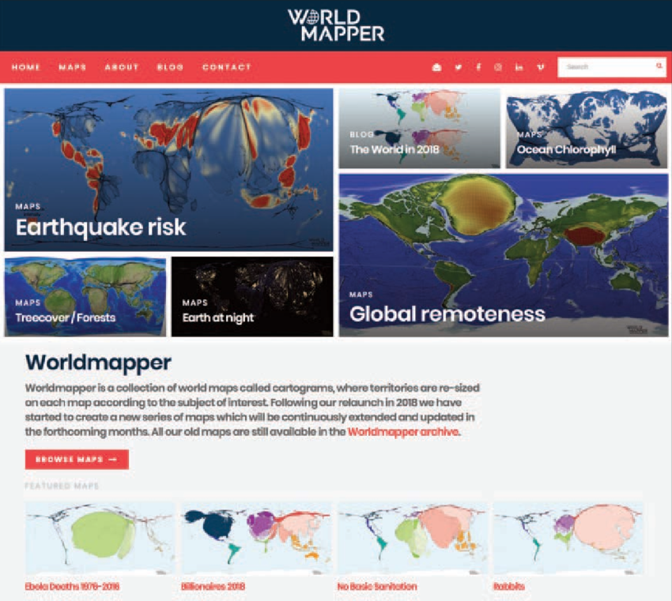

**1. Filtering:** Users can explore a vast array of datasets by selecting a topic of interest from a wide range of categories like health, economy, education, and environment. This filters the map display to show data relevant to the chosen topic.

**2. Focus + Context:** Worldmapper uses a unique approach to visualize data. Countries are distorted in size based on the chosen dataset. For example, a map displaying population might show heavily populated countries like China and India much larger than others. This creates a strong visual focus on the data while still maintaining the overall world map as context.

**3. Zoom and Pan:** Users can zoom in on specific regions of the map to see data details for individual countries. Additionally, Panning allows them to explore different parts of the world and compare data across regions.

**4. Tooltips:** Hovering over a country reveals a tooltip with additional information relevant to the chosen dataset. This provides context and specific values for each data point.

**5. Color Coding:** Worldmapper often employs color coding to categorize data. For instance, a map displaying health might use different colors to represent varying levels of life expectancy across countries. This helps users visually identify patterns and trends.

By combining these interactive features, Worldmapper allows users to effectively explore and understand complex global datasets. They can filter topics, zoom in on specific regions, and leverage tooltips and color coding to gain deeper insights into the data without feeling overwhelmed by information.

**2.4 Please describe how the interaction example in 2.3 can be further improved in your opinion. (10)**

**Ans: Potential Improvements for Worldmapper Interactions:** While Worldmapper effectively utilizes various interactions, here are some ideas for further improvement:

**1. Enhanced Filtering and Search:** Advanced filtering options: Allow users to filter data by multiple criteria simultaneously (e.g., population density and literacy rate) for more nuanced exploration.

**Search functionality:** Implement a search bar to let users quickly find specific datasets by keyword or topic.

**2. Layering and Brushing:** Data layering: Enable users to overlay multiple datasets on the map simultaneously (e.g., population density with income levels). This can reveal interesting correlations and interactions between different factors.

**Brushing:** Allow users to brush (select) a region on the map and see how that selection affects other visualizations or data tables. This can enhance the connection between map data and additional details.

**3. Comparative Analytics:** Comparative view: Provide a side-by-side comparison of data for selected countries. Users could choose multiple countries and see their data displayed in charts or tables alongside the map.

**4. User-Generated Content and Sharing:** Annotation tools: Allow users to add annotations or highlights to specific regions on the map and share them with others. This can facilitate collaborative exploration and knowledge sharing.

**Downloadable visualizations:** Enable users to download map images or data in various formats for further analysis or presentation.

**5. Accessibility Features:** Colorblind-friendly palettes: Implement color schemes that cater to users with color vision deficiency to ensure everyone can access the information effectively.

**Interactive audio descriptions:** Provide audio descriptions of the data visualization for visually impaired users.

These improvements can further empower users to explore big data, identify relationships, and gain deeper insights from the information presented on Worldmapper.